Our objective is to create a recreation activity such as a game in micro-gravity. Amongst all the challenges offered, we chose “Space Recreation” under “Journey to Mars”. The challenge wants us to design a game that can be played in micro-gravity conditions and that requires only some easily available materials to play. Such a game would be very useful as we come to the topic of space colonisation, which is expected the near future.

As the team, we were very interested in the idea and wanted to design something very creative. As we came across the properties of water in space, we decided its the thing, because water in space is so awesome and its something very common.

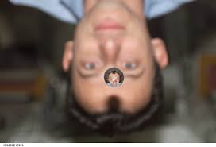

Other things like a small amount of colouring pigment, which when hitting with another water bubble, combines and make the bubble coloured. Here we brought the idea of mixing of colours. So when a green and a blue bubble join, then a bigger magenta bubble. Water also gets repelled by some materials like silica. So taking all these ideas together we designed a game which is so cool.

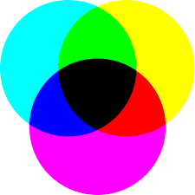 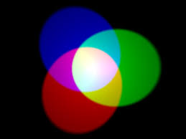

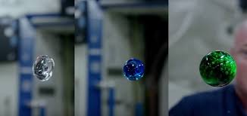

The game is played between two teams, each having 3 members each. Each member gets a syringe which is filled with the colouring pigment. The syringe also operates in a slightly different way, which is it fire water only in specific amounts, like a drop at a time. A player also gets a circular disk which is water repellent. As the game begins there will be some bubbles floating around the players and the players are allowed to control the floating bubbles using the repelling plates and they can fire the pigment at the bubble to make them the coloured bubble as they want it.

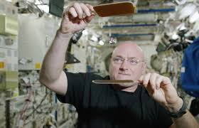

The colouring pigments for one team are red, blue and green. And for the other team the colours are cyan, magenta and yellow. The objective of the game is different for the teams. For the RBG team the aim is to make a white big bubble (combination of at least 3 bubbles which are there as the game started) and for the CMY team, the goal is to make a black big bubble. So simple.

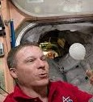 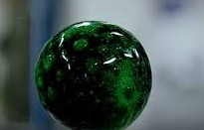

The rules are logical. The players should not do anything to bubble except colouring them with the pigment or controlling with the plate.

This game is more like a brain game and the team members can plan on it together and act. The players should have a clear idea about the movement of the bubbles and thereby time their shots perfectly. They can prevent hitting of combining of two bubbles by using the repelling disk.

The whole game will be played with a circular boundary with the players outside it and bubbles inside it. The bubble will, obviously, moving slowly and this gives the players enough time to think on and do something bright.

So that’s it. A wonderful game for the tired brains that give you both exercise and pleasure.